The TEFL University PHD Course
Module 5

Module Notes:
Make sure that you save your course-work as you go along!
You must also add your full name to the end of the file name of this document before you start. For example; with this module which is currently saved as:
phd-module5-TEFL-722-yourname
To change the file name, simply go to the top left of your screen, and click on File, Save As, then change the name of the file by simply adding your name to the end of the existing file name and save the module to a folder on your computer (‘My Documents’ for example). As an example; if your name were Jane Mortimer, you would save the file as:
phd-module5-TEFL-722-Jane-Mortimer
Submitting your completed modules
Once you have completed a module, you may use the link below to re-visit the course download/upload area, where you will find the drop-box to send your completed work back to us. Please note that grading will not commence until all modules are fully completed:

http://www.thetefluniversity.com/phd-course-download.html

TEFL 722—Discourse Analysis in Language Teaching
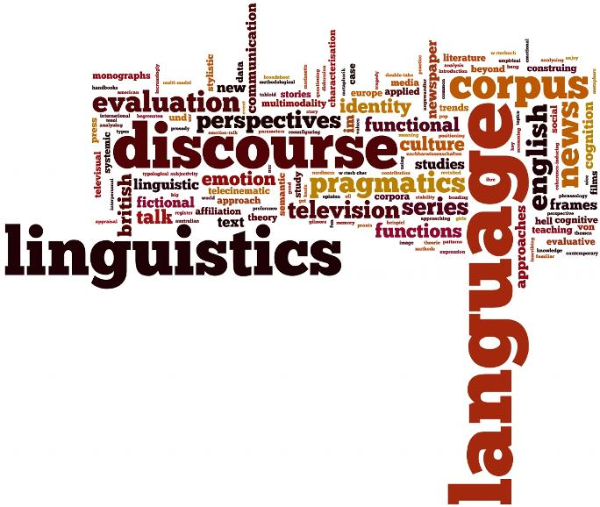
Course Description
This module offers M-Level and IPHD students an opportunity to gain familiarity with discourse analytic approaches to analysing language for teaching purposes. It offers both a theoretical and practical understanding of the key concepts associated with discourse analysis, focusing especially, but not exclusively, on spoken discourse. The module explains how discourse analysis is essential for effective language teaching and learning, and gets learners to think beyond the level of sentence. In addition, students will learn how to make use of spoken and written texts in their teaching and how to analyze their own discourse in the context of classroom discourse.
Course Goals
By the end of this course, students will be able to:
- Understand how discourse is different from other core aspects of language.
- See how discourse analysis changes the way we think of language learning.
- Understand how the way teachers communicate with learners can affect learning.
- Design and edit language teaching dialogues and other spoken materials so that they focus more on discourse and are more natural and realistic.
- Analyze language using spoken and written texts
- Teach and support learning through discourse analytic approaches to language
- Adapt both spoken and written texts for teaching purposes
- Make use of a range of text types in their teaching

Required reading:
Textbook (required):
McCarthy, Michael. 1991. Discourse Analysis for Language Teachers. Cambridge: CUP
Available for download at:
http://modules.mindset.net.br/assets/HWS/training/downloads/20110620_154614_wiseup_distance_training_program_day_1_-_4._discourse_analysis_for_language_teachers_by_michael_mccarthy.pdf
Alternative download link:
https://drive.google.com/open?id=1fsB3FU94za2MLy6pPjj5E5JmQqgQ1Z3p
Powerpoint presentation:
http://www.kln.ac.lk/units/eltu/pdf/dushymendis.pdf
Alternative download link:
https://drive.google.com/open?id=17rMOZlRd3LCioJ8ZKB-sJzO8EczUl4km

Academic Integrity
All work submitted must be your own or must be properly documented. Collaborative work and work previously submitted in another class must be approved in advance.
Assignment Descriptions
Many academics have debated the role of discourse analysis in the classroom. The traditional view holds that it is one more level of a language to teach.
Available for download at:
https://periodicos.ufsc.br/index.php/desterro/article/viewFile/11658/11213
Alternative download link:
https://drive.google.com/open?id=1UJSgLWZxV72EZTUqXbed9t1GVCx1UFV7
Others have held that discourse analysis requires a complete change in teaching perspective.
Available for download at:
http://www.raco.cat/index.php/linksletters/article/viewFile/49847/87827
Alternative download link:
https://drive.google.com/open?id=1nCDfP2X5qwjBMLaJZG6ZdGMN5u7zNUs4
You are required to write a research paper arguing your view for the proper application of discourse analysis in 2L teaching. Your paper must be at least 1000 words in length, and must be supported extensively with your research. You may use journal articles, trade publications or other sources.
You may start your essay below

